**Assignment 1** :- Create an IAM user with username of your own wish and grant

administrator policy.

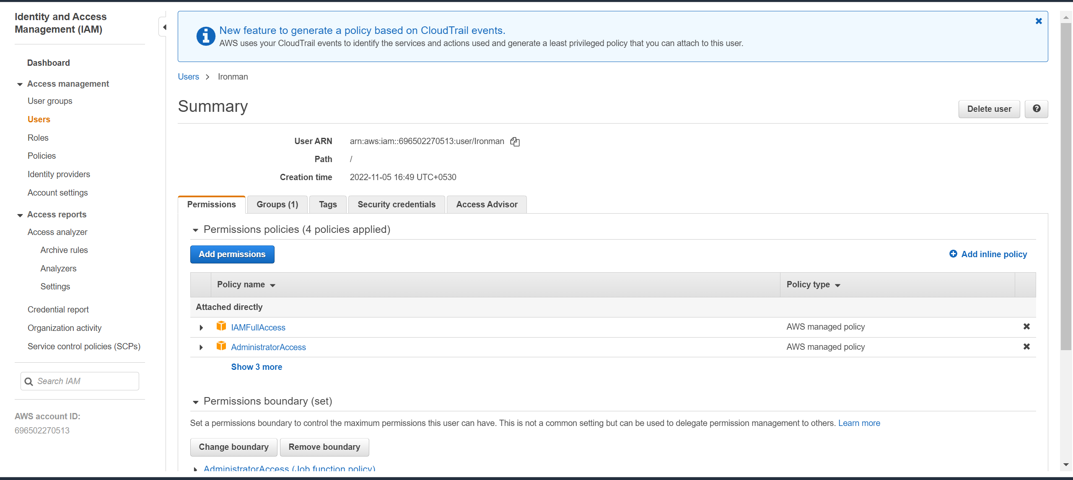

**Assignment 2** :- Hello students, in this assignment you need to prepare a

developers team of avengers.

- Create 3 IAM users of avengers and assign them in developer’s groups with

IAM policy.

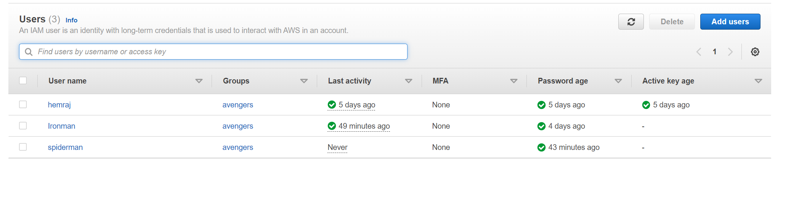

**Assignment 3** :- Define a condition in policy for expiration like

"DateGreaterThan": {"aws:CurrentTime":

"2020-04-01T00:00:00Z"},

"DateLessThan": {"aws:CurrentTime":

"2020-06-30T23:59:59Z"}

Define the span of 4 months as per your wish

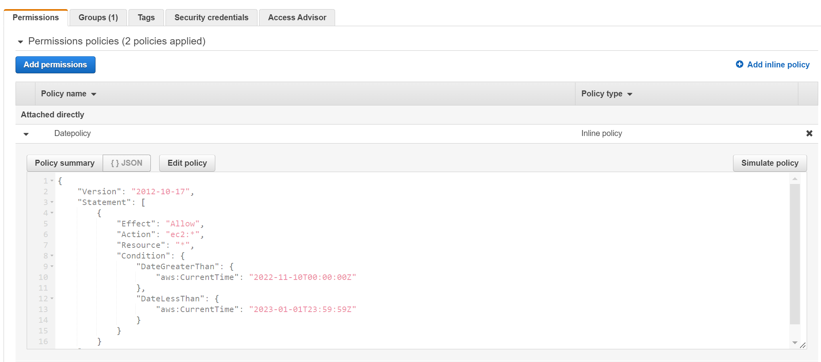

**Assignment 3** :- Prepare 15 authentic MCQ questions related to IAM.

1.

Identify the wrong statement.

(a) Identity and access management (IAM) is a framework for business processes that facilitates the management of electronic or digital identities

**(b) With IAM technologies, IT managers can control user access to critical information within their organizations**

(c) Identity and access management products offer role-based access control

(d) In IAM roles are defined according to the ability of an individual user to perform a specific task, such as view, create or modify a file

2. Which of these is Identity in IAM?

(a) Users

(b) Groups

(c) Roles

(d) All of these

3. When you first create an Amazon Web Services (AWS) account, you begin with a single sign-in identity that has complete access to all AWS services and resources in the account. This identity is called:

(a) Root user

(b) Main user

(c) Super user

(d) None of these

4. An IAM user:

(a) is an entity that you create in AWS

(b) is to give people the ability to sign in to the AWS Management Console for interactive tasks and to make programmatic requests to AWS services using the API or CLI

(c) A and B both

(d) None of these

5.Choose the below statements are true or false for AWS:

1. When you create an IAM user, you grant it permissions by making it a member of a group that has appropriate permission policies attached (recommended), or by directly attaching policies to the user

2. You can also clone the permissions of an existing IAM user, which automatically makes the new user a member of the same groups and attaches all the same policies.

(a) 1. True, 2. True

(b) 1. True, 2. False

(c) 1. False, 2. True

(d) 1. False, 2. False

6. IAM group:

(a) Is same as IAM users

(b) Can be used to specify permissions for a collection of users

(c) Is truly an identity

(d) All of these

7. Which of these is IAM principal?

(a) A user

(b) A role

(c) An application

(d) All of these

|  |  |  |  |  |  |  |  |  |
| --- | --- | --- | --- | --- | --- | --- | --- | --- |
| **8. IAM role:**   |  |  | | --- | --- | | (a) | Have credentials (password or access keys) associated with it | | (b) | Does not have any credentials (password or access keys) associated with it | | (c) | May or may not have credentials (password or access keys) associated with it | | (d) | None of these | |

|  |  |  |  |  |  |  |  |  |  |
| --- | --- | --- | --- | --- | --- | --- | --- | --- | --- |
| **9.** | **Temporary credentials:**   |  |  | | --- | --- | | (a) | It expires automatically after a specified time | | (b) | Have a same set of permissions that your standard IAM user have | | (c) | We can have control over the duration that the credentials are valid | | (d) | A and C both | |

|  |  |  |  |  |  |  |  |  |  |
| --- | --- | --- | --- | --- | --- | --- | --- | --- | --- |
| **11.** | **AWS supports ______ types of policies.**   |  |  | | --- | --- | | (a) | 4 | | (b) | 5 | | (c) | 6 | | (d) | 7 | |

|  |  |  |  |  |  |  |  |  |  |  |
| --- | --- | --- | --- | --- | --- | --- | --- | --- | --- | --- |
| **12. Which of these is not an IAM policy type?**   |  |  | | --- | --- | | (a) | Smart policies | | (b) | Access control lists (ACLs) | | (c) | Session policies | | (d) | Organizations SCPs | |  |  |

**13. Names of IAM identities (users, roles, and groups):**

|  |  |
| --- | --- |
| (a) | Must be unique within the AWS account |
| (b) | Must be unique within the availability zone |
| (c) | Must be unique within the region |
| (d) | Must be unique within the AWS cloud whole |

**14 How many maximum groups can be created in an AWS account?**

|  |  |
| --- | --- |
| (a) | 25 |
| (b) | 50 |
| (c) | 100 |
| (d) | 200 |

|  |  |  |  |  |  |  |  |  |  |
| --- | --- | --- | --- | --- | --- | --- | --- | --- | --- |
| **15.** | **Identify the wrong statement.**   |  |  | | --- | --- | | (a) | IAM can provide shared access to the AWS account | | (b) | IAM is paid service in AWS | | (c) | IAM can provide granular permissions | | (d) | IAM supports multifactor authentication | |

**Assignment 4** :- Launch your linux instance in IAM and update your machine.

